Practical 4

Problem Definition

Develop a calculator feature that finds the factorial of a number. Implement nested functions and demonstrate scope handling.

Code

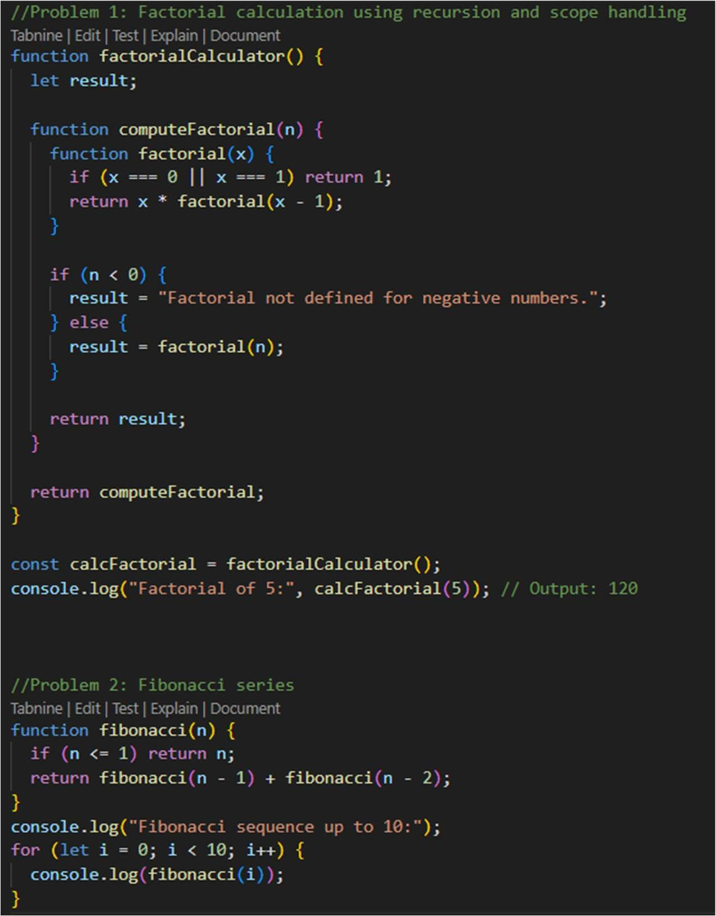

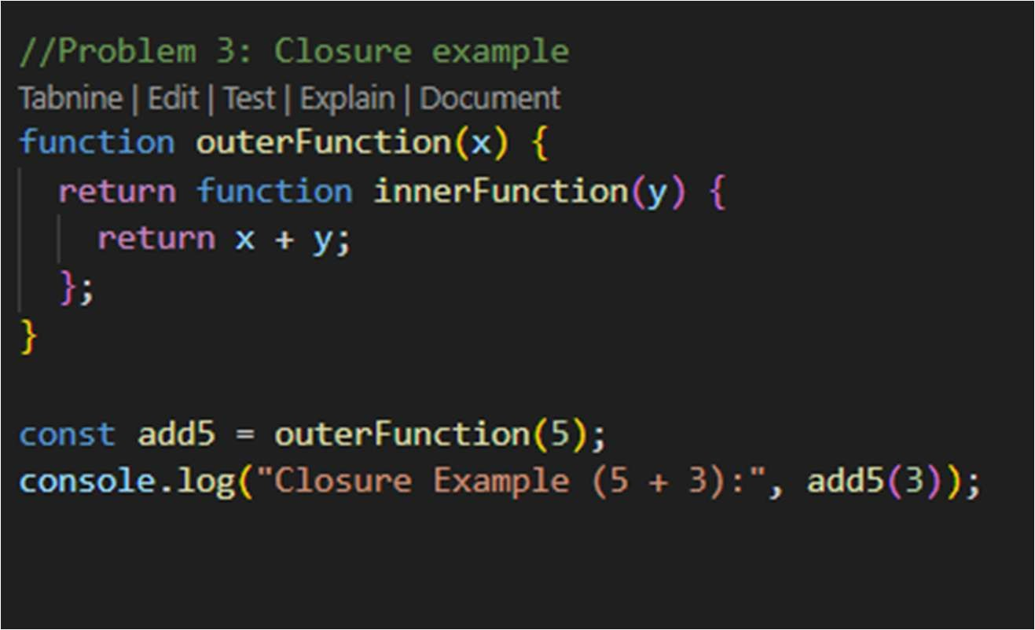

Output: 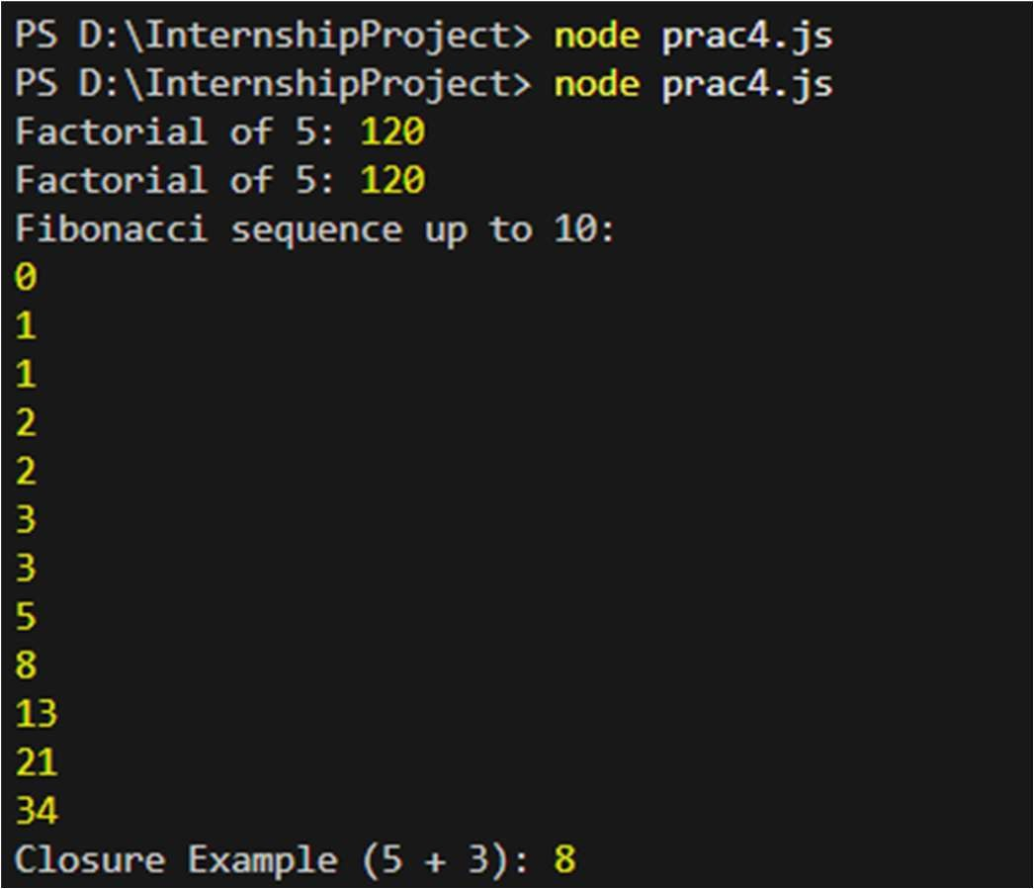

Practical 5

Problem Definition:

A transport company needs a system to manage different types of vehicles. Build a base class and extend it for cars and motorcycles.

Code:

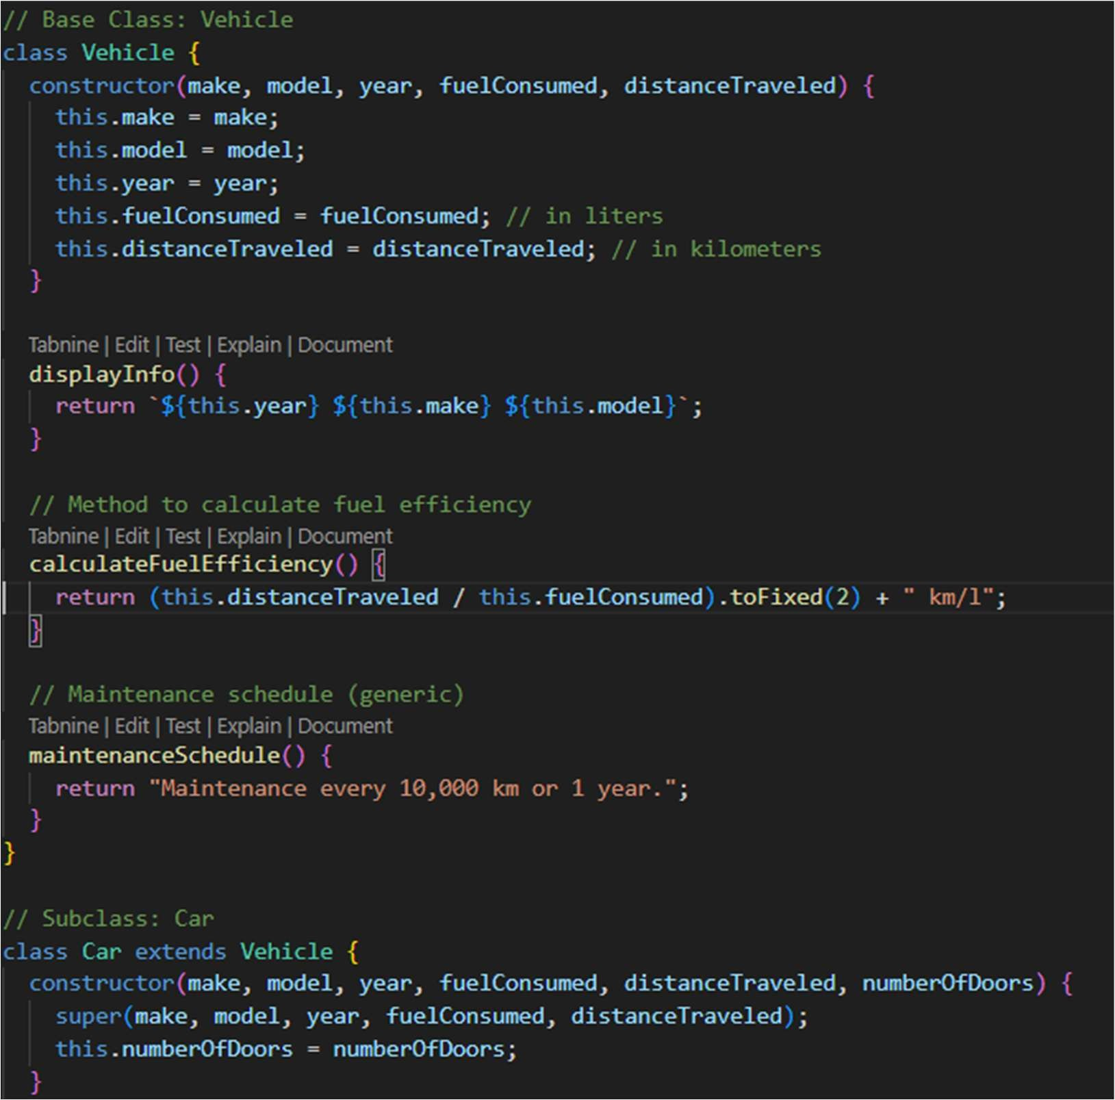

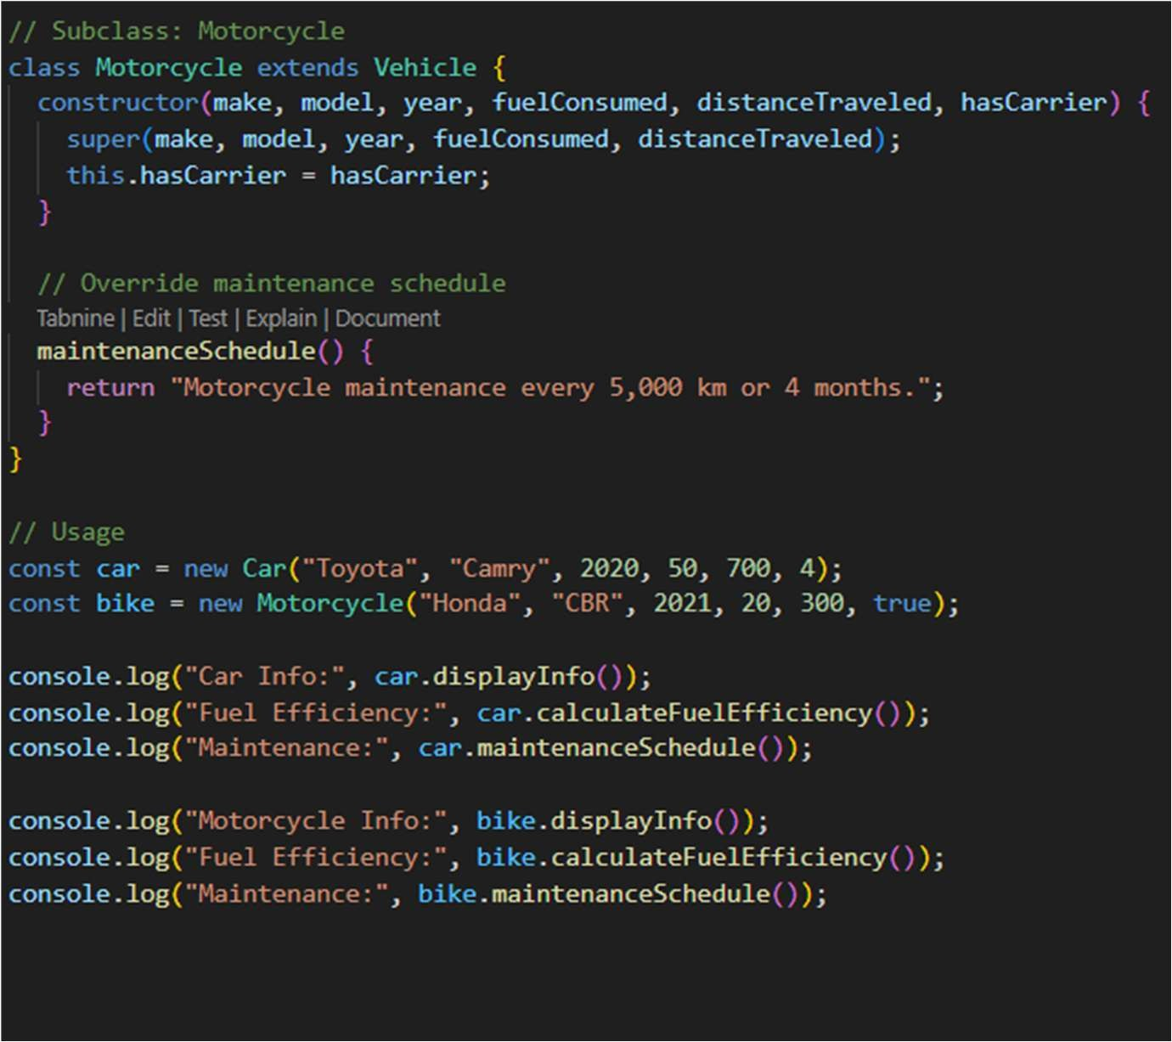

Output:

